Cointegration and ECM: EURUSD and NZDUSD
Method 27 / Engle-Granger on log closes / one-lag ECM / Alpari D1 full available history

Study setup
Logical pair: PX=EURUSD , PY=NZDUSD
Broker symbols: EURUSD_i , NZDUSD_i
Snapshot: 2026-11-03_majors_alpari_D1
Timeframe: D1
Matched window: 1999-01-05 to 2026-11-02 (UTC bar dates)
Matched level count n: 7186
Dropped unfinished last bar dated 2026-11-03 UTC after a tick-volume check against the prior complete day.
ECM lags of deltas: 1
Complete matched rows (Excel): EURUSD-NZDUSD_Coint_D1.xlsx
Complete matched rows (HTML table): EURUSD-NZDUSD_Coint_D1_data.html

Method carried forward
Engle-Granger cointegration works on log price levels, not returns. For each unordered pair, PX is the left leg and PY the right leg. Step one: OLS ln(PY) = alpha + beta * ln(PX) + e. Step two: statsmodels Engle-Granger coint test on (ln(PY), ln(PX)). Error-correction: delta ln(PY)_t = c + kappa * e_{t-1} + lagged delta ln(PY) and delta ln(PX) (one lag each) + u_t. Headline is the Engle-Granger p-value (lower = stronger evidence of a stationary spread) with kappa and beta reported alongside. Same-sample Pearson r of log returns is a side check only. beta is not an automatic lot-size hedge. This is not a trading signal.

Results (headline)
alpha: -0.610114
beta: 1.101393
Engle-Granger t: -2.854952
Engle-Granger p: 0.148825
5% critical value: -3.336981
ECM kappa: -0.002364
kappa t-stat: -2.7169
ECM R^2: 0.001503
spread std: 0.103631
Pearson r (returns): 0.549808

Conclusion
Engle-Granger for PY=NZDUSD on PX=EURUSD: beta=1.1014, alpha=-0.6101, coint_t=-2.8550, p=0.1488 (5% crit=-3.3370). ECM kappa=-0.0024 (t=-2.72). Pearson r of returns = 0.5498. beta is not a lot-size hedge. Not a trading signal.

Charts
Daily closes

Engle-Granger residual spread
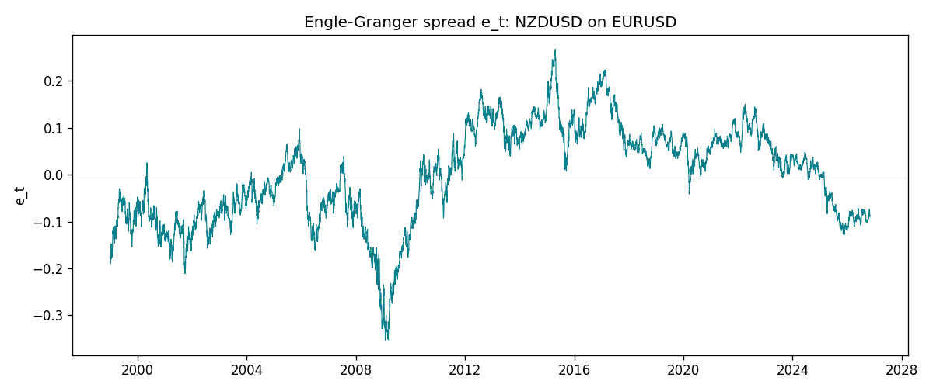
Daily log returns
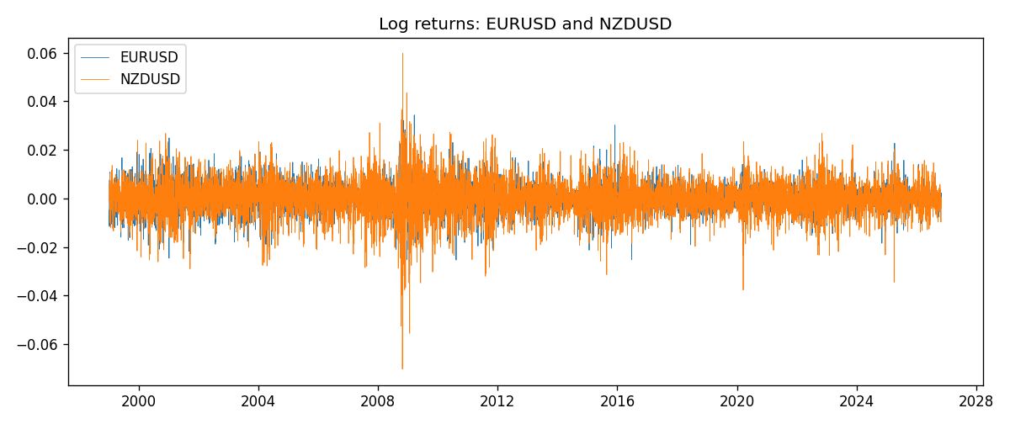

Data report
Matched rows are in the sibling Excel workbook named EURUSD-NZDUSD_Coint_D1.xlsx. Embedding all rows as a Word table is impractical; this file holds column summaries and the first and last 15 matched rows.
Column summaries
column | count | mean | std | min | 25% | 50% | 75% | max
EURUSD_open | 7186 | 1.181357 | 0.15085833 | 0.8272 | 1.086165 | 1.16609 | 1.2939475 | 1.5995
NZDUSD_open | 7186 | 0.65641776 | 0.10819833 | 0.3913 | 0.59134 | 0.6684 | 0.7249075 | 0.88218
EURUSD_high | 7186 | 1.1864878 | 0.15145386 | 0.8326 | 1.09024 | 1.17121 | 1.2993075 | 1.6038
NZDUSD_high | 7186 | 0.66033433 | 0.10869188 | 0.3961 | 0.59475 | 0.67202 | 0.72936 | 0.88421
EURUSD_low | 7186 | 1.1763494 | 0.15017707 | 0.8227 | 1.082045 | 1.162475 | 1.2884175 | 1.5865
NZDUSD_low | 7186 | 0.65273031 | 0.10779283 | 0.3897 | 0.5880725 | 0.664185 | 0.720965 | 0.87988
EURUSD_close | 7186 | 1.1813978 | 0.15082738 | 0.8267 | 1.0860425 | 1.16602 | 1.2939725 | 1.5997
NZDUSD_close | 7186 | 0.65649194 | 0.10819527 | 0.3907 | 0.59159 | 0.66842 | 0.725015 | 0.8822
EURUSD_tick_volume | 7186 | 103205.25 | 173535.32 | 218 | 9413.25 | 52774.5 | 99579.75 | 1471626
NZDUSD_tick_volume | 7186 | 68709.014 | 123134.25 | 16 | 5585.5 | 33893.5 | 58510.5 | 1127682
EURUSD_spread | 7186 | 19.350682 | 16.562781 | 0 | 8 | 12 | 27.5 | 50
NZDUSD_spread | 7186 | 30.284303 | 25.649992 | 0 | 9 | 17 | 47.5 | 80
EURUSD_real_volume | 7186 | 4.0330482e+10 | 1.6691688e+11 | 0 | 0 | 0 | 0 | 3.6149665e+12
NZDUSD_real_volume | 7186 | 1.6701379e+10 | 8.497804e+10 | 0 | 0 | 0 | 0 | 2.705649e+12
EURUSD_log_price | 7186 | 0.15845131 | 0.12905748 | -0.19031341 | 0.08254036 | 0.15359624 | 0.25771694 | 0.46981611
NZDUSD_log_price | 7186 | -0.43559715 | 0.17590908 | -0.93981528 | -0.52494145 | -0.40283856 | -0.32156293 | -0.12533649
EURUSD_log_return | 7186 | -4.99e-06 | 0.00579654 | -0.03123819 | -0.00323792 | 0 | 0.00325328 | 0.03433183
NZDUSD_log_return | 7186 | 9.3e-06 | 0.0076423 | -0.07027433 | -0.00425367 | 0.00022883 | 0.00457975 | 0.05966839
spread_e | 7186 | -0 | 0.10363096 | -0.35353018 | -0.08017341 | 0.01335258 | 0.07967465 | 0.26724062
ecm_fitted | 7185 | 9.56e-06 | 0.0002963 | -0.00101179 | -0.0001935 | -1.47e-05 | 0.00020105 | 0.0019162
First 15 matched rows (selected columns)
time | EURUSD_log_price | NZDUSD_log_price | spread_e | EURUSD_log_return | NZDUSD_log_return
1999-01-05 | 0.16194877 | -0.62138481 | -0.18963974 | -0.0048360507 | -0.0018597736
1999-01-06 | 0.1504008 | -0.61933925 | -0.17487533 | -0.011547966 | 0.0020455609
1999-01-07 | 0.15802886 | -0.61304294 | -0.1769805 | 0.0076280636 | 0.0062963171
1999-01-08 | 0.14712606 | -0.6135969 | -0.1655262 | -0.010902799 | -0.00055396548
1999-01-11 | 0.14002278 | -0.60330648 | -0.14741227 | -0.007103287 | 0.010290425
1999-01-12 | 0.14453315 | -0.60862223 | -0.15769571 | 0.0045103728 | -0.0053157489
1999-01-13 | 0.1553785 | -0.61859645 | -0.17961492 | 0.010845346 | -0.0099742238
1999-01-14 | 0.1553785 | -0.6187821 | -0.17980057 | 0 | -0.00018564931
1999-01-15 | 0.14522525 | -0.61952504 | -0.1693608 | -0.010153245 | -0.00074294208
1999-01-18 | 0.14885095 | -0.62138481 | -0.17521389 | 0.0036256946 | -0.0018597736
1999-01-19 | 0.14867859 | -0.61952504 | -0.17316429 | -0.00017235436 | 0.0018597736
1999-01-20 | 0.14548467 | -0.61544567 | -0.16556715 | -0.0031939256 | 0.0040793678
1999-01-21 | 0.14850621 | -0.61138288 | -0.16483226 | 0.0030215416 | 0.0040627941
1999-01-22 | 0.14729869 | -0.62343457 | -0.175554 | -0.0012075213 | -0.012051689
1999-01-25 | 0.14427349 | -0.62698498 | -0.17577247 | -0.0030251979 | -0.0035504102
Last 15 matched rows (selected columns)
time | EURUSD_log_price | NZDUSD_log_price | spread_e | EURUSD_log_return | NZDUSD_log_return
2026-10-13 | 0.11301614 | -0.57755321 | -0.091914076 | 0.0037402957 | 0.0047326165
2026-10-14 | 0.10925791 | -0.58128385 | -0.091505441 | -0.0037582255 | -0.0037306483
2026-10-15 | 0.11486322 | -0.57652037 | -0.092915605 | 0.0056053107 | 0.0047634855
2026-10-16 | 0.11663571 | -0.57077027 | -0.089117712 | 0.0017724895 | 0.0057501001
2026-10-19 | 0.11409625 | -0.56887856 | -0.084429052 | -0.0025394633 | 0.0018917133
2026-10-20 | 0.11648442 | -0.56515862 | -0.083339429 | 0.0023881672 | 0.0037199341
2026-10-21 | 0.11616395 | -0.56206629 | -0.079894135 | -0.00032046717 | 0.0030923331
2026-10-22 | 0.11456899 | -0.56536981 | -0.08144098 | -0.0015949606 | -0.0033035227
2026-10-23 | 0.11323047 | -0.56227683 | -0.076873757 | -0.001338521 | 0.0030929853
2026-10-26 | 0.11095981 | -0.56517622 | -0.077272266 | -0.0022706559 | -0.0028993932
2026-10-27 | 0.10680747 | -0.56544022 | -0.072962904 | -0.004152342 | -0.00026399852
2026-10-28 | 0.10903376 | -0.57516861 | -0.085143319 | 0.0022262927 | -0.0097283914
2026-10-29 | 0.1112909 | -0.5745467 | -0.087007404 | 0.0022571351 | 0.00062190714
2026-10-30 | 0.11014505 | -0.57435132 | -0.085550002 | -0.0011458446 | 0.00019537668
2026-11-02 | 0.11226562 | -0.57694762 | -0.090481877 | 0.002120569 | -0.0025962955

